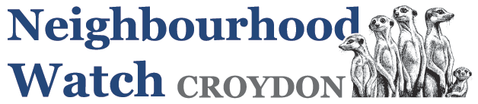

**Crime Prevention Day 2024**

**Croydon Borough Neighbourhood Watch Association**

Our CPD will be held on the 12th October 2024 at Royal Russel School from 8-30am registration and coffee, main event 9-00am to 3-15pm with the AGM following from 3.15pm to 4.00pm

This year access will be free as we have had sufficient monies from people using the Croydon Community Lottery via CVA to pay for this event.

However, we still need to people to register that they will be attending so we can make the necessary catering arrangements, so please reply to nhw@cbnhwa.com.

The speakers we have lined up are currently as follows:

1. Jason Perry, Croydon Elected Mayor
2. Councillor Ola Kolade, Croydon Council Cabinet Member for Community Safety.
3. Superintendent Mitch Carr
4. Croydon Safer Neighbourhoods Inspectors
5. John Hayward-Cripps, Chief Executive, National Neighbourhood Watch Network
6. Croydon Community Against Trafficking
7. Croydon Trading Standards
8. Caspar Kennerdale, Managing Director, Clear Community Web (Talking about cybercrime)
9. Chris Philip, previously MP Croydon South, Minister of State for Crime, Policing and Fire (until 30/5/24). Subject to election.